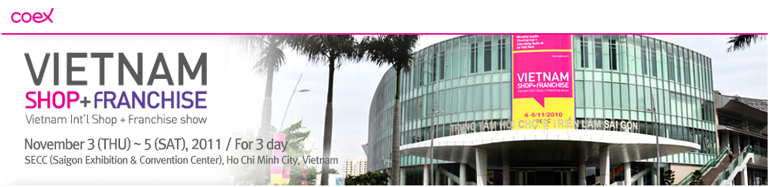
Vietnam International Shop+Franchise Show 2011
Venue
SECC (Saigon Exhibition & Convention Center), Ho Chi Minh City, Vietnam
Address: 799 Nguyen Van Linh, Tan Phu Ward, 7 District, Ho Chi Minh City (SECC is located at the center of Phu My Hung new urban. It takes 15 minutes from city center to SECC and 30 minutes from Tan Son Nhat international airport)
Period
November 3 (Thur.) ~ 5 (Sat.), 2011
Organizer
Korea International Trade Association (KITA), Coex Co,.Ltd
Supporter (undecided)
Korea Ministry of Knowledge Economy, Korea Small & Medium Business Administration,
Korea Ministry of Knowledge Economy Overseas Investment Support Council, Institute of Korea Entrepreneurship Development, Korea Franchise Association, Association of Korea Exhibition Industry, Embassy of Vietnam in Korea, Ministry of Industry & Trade Vietnam, Vietnam Small & Medium Enterprise Association, Vietnam Retailer's Association, Vietnam Supply Chain Association, Franchise-Vietnam, Vietnam Architects Association, Malaysia Franchise Association, Japan Franchise Association, Philippine Franchise Association, etc.
Exhibition items
- Vietnam Shop
Shop design and renovation: Shelves, Furnishing, Mannequins, LCD/PDP, Signage, POP displays, Interior items, Etc.
Shop equitment: Showcase, Freezers, Heating Cabinets, Cleaning equipments, Cooking utensils, Fan, Cart, Wrapping machines, Etc.
Retail Technology: Payment system, POS system, Security system, Safes, A/V system, Bar-code system, RFID system, Etc.
Professional Service: Consulting on shop management/operation, Real estate, Finance, Insurance and Others:
Retail Purpose Items: Distribution purposed item through distribution channels specialzing in Vietnam and Indo-China
- Vietnam Franchise 2011
Food and Beverage: ast-food, Traditional Vietnam and overseas cuisine, Cafe/Bar, Etc.
Beauty and Health: Hair/Makeup, Cosmetics, Spa, Supplementary health food, Hospital, Etc.
Fashion: Clothes/Shoes, Accessories, Etc.
Consulting Service: Various consultation concerning Real estate, Finance, Insurance, Etc.
Education and Traning: Various education related business (Child education, High education, Professional education, Etc.)
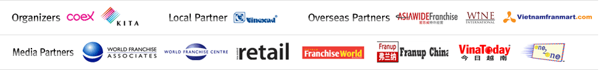
Others Specialized retail stores: Automobiles and motorbikes repair shops including selling parts, specialized franchise items such as laundry stores.

